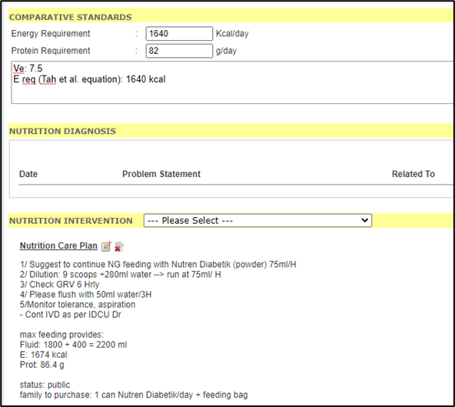
The figure above shows that Tah et al. equation was used in the Comparative Standards in the iPesakit system UMMC to calculate energy requirement for ventilated critically ill patients before nutrition intervention done by dietitians in UMMC.
