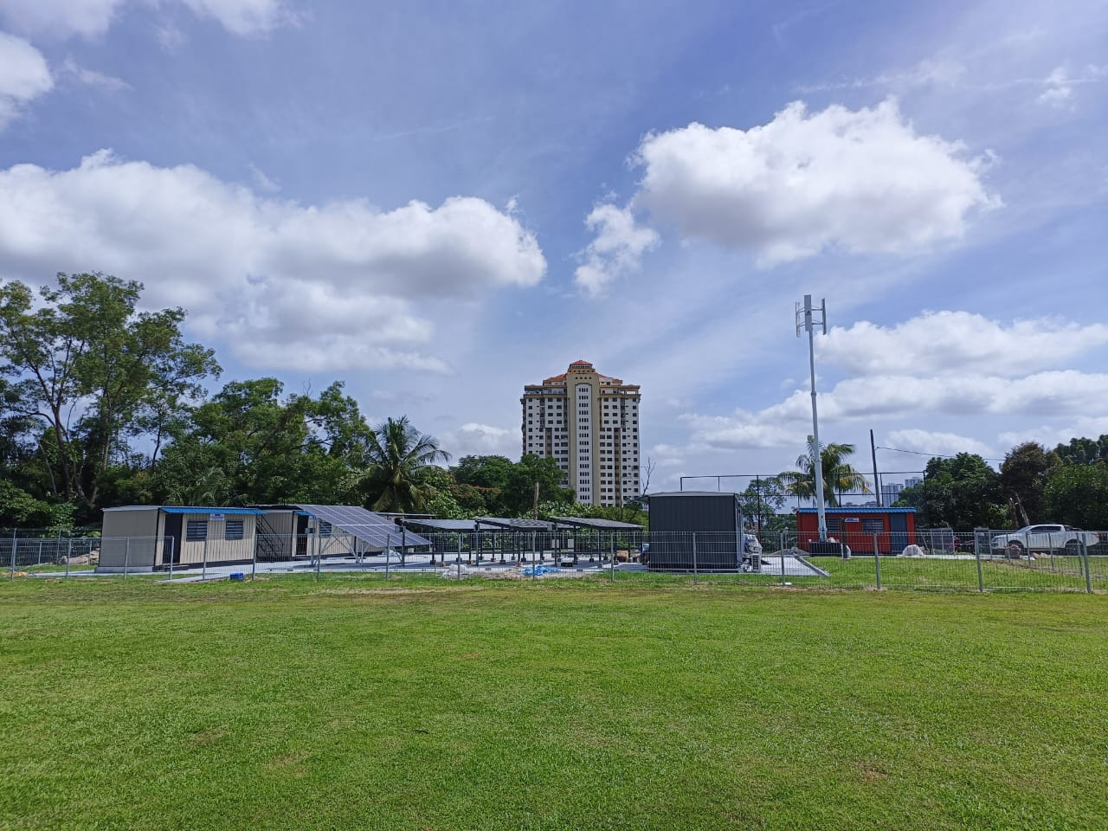

Group Member:

1. Ts. Khamelrun Shah Bin Mat Jamil 760223-12-5217
2. Norhatini binti Ibrahim 840326-13-5768
3. Mohammad Hamdi Bin Latip 950617-01-7507
4. Muhamad Fairaus Bin Sahrani 011231-01-1465
5. Nur Amna Nafeesa Binti Amy Azfarudin 041222-10-1722

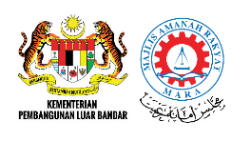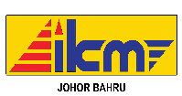

**SYNOPSIS**

Nowadays, solar technology is one of the new technologies that produce electricity. There are various types of solar systems used in housing and industry such as Off-grid system, on-grid system, hybrid system and so on to generate electricity. One of the systems that can be learned is the Hybrid solar system which combines supply volume such as wind, solar and power to produce a continuous source of energy.

For the purpose of facilitating the learning and teaching process, there are innovation designs to facilitate the implementation of the solar hybrid system learning process for those who intend to explore new knowledge related to renewable energy

Hybrid Solar System, for solar system part using panel solar, solar charger controller, voltage meter, ampere meter. The function of solar controller charge is solar charge controller manages the power going into the battery bank from the solar array. It ensures that the deep cycle batteries are not overcharged during the day, and that the power doesn’t run backwards to the solar panels overnight and drain the batteries.

Wind system part is wind turbine, wind charge controller, dynamo, and inverter. Wind turbines work on a simple principle: instead of using electricity to make wind like a fan wind turbine use wind to make electricity. Wind turns the propeller-like blades of a turbine around a rotor, which spins a generator, which creates electricity.