TITLE : SOAP AS MUSCLE SORENESS TREATMENT,
FOCUSING ON DELAYED ON-SET MUSCLE SORENESS (DOMS)

ABSTRACT

Research has shown that a significant number of student athletes in sports schools experience muscle soreness, with young women being more susceptible to muscle aches compared to young men (Julia S. Malmborg, 2022). This is due to the higher levels of the hormone estrogen in women's bodies, which leads to lower resting levels of creatine kinase in their muscles, a marker for muscle damage. However, estrogen has a positive impact on muscle cells, allowing women to recover faster from muscle damage. DOMS, or Delayed Onset Muscle Soreness, is a type of muscle strain injury that results in a painful, aching, and sore feeling in the muscles after intense exercise that is unfamiliar or unaccustomed. It can affect athletic performance and is common among athletes who are first introduced to certain types of activities. People describe DOMS as a tender, tired, and burning sensation in specific areas of the body, with tight and achy muscles preventing them from carrying out usual activities. It is important for young women to stay active and take care of their physical health despite the challenges posed by DOMS.

PROBLEM STATEMENT

Delayed onset muscle soreness (DOMS) is a common experience for people who push themselves to their limits during exercise or who have been inactive for an extended period and suddenly start exercising. DOMS is characterized by pain and stiffness felt in muscles a few hours to several days after unaccustomed or strenuous exercise. It is caused by eccentric contractions of the muscle during exercise and is most severe 24 to 72 hours after the workout. DOMS can be a sign that the body is adapting to new levels of activity, but it can also be painful and uncomfortable.

DETAILS OF THE INGREDIENTS USED :

CHERRY
Cherry consumption has been linked to reducing arthritic pain and may have potential to lower risk of cardiovascular and chronic diseases due to its high levels of anthocyanins and cyanidin with strong antioxidant and anti-inflammatory properties. There is study shown that cherry consumption had statistically significant lower levels of inflammation markers (IL-6 and CRP) as compared to placebo. (Kuehl K. S., 2013)

GINGER

Ginger has been shown to reduce muscle pain intensity 24 hours post exercise due to its anti-inflammatory and analgesic properties. 11 days of dietary supplementation with 2g of raw or heat-treated ginger resulted in a 25% and 23% reduction in muscle pain respectively. (Cristopher D. Black, 2011).

CINNAMON
Cinnamon bark has been used for both flavoring and medicinal purposes. Studies suggest that cinnamon extract can reduce inflammation and pain, with consistent results from randomized trials showing reduced acute-phase inflammation response after daily intake. (Dominic Klein, 2003).

TURMERIC
Curcumin, a component of turmeric, has anti-oxidant properties and has been investigated for its beneficial effects on inflammation and pain relief. Studies have shown that curcumin suppresses the activation of NF-κB, which plays a role in muscle proteolysis and inflammation, potentially providing a muscle-protective effect. (Nima Alamdari, Ph. D, 2008).

GARLIC
Garlic and its constituents have been shown to have various biological actions including antioxidant and anti-inflammatory effects. Allicin, produced when garlic cloves are crushed, may reduce muscle soreness and inhibit the increase in plasma IL-6 after eccentric exercise. Studies suggest that allicin supplementation may be beneficial in reducing muscle damage after exercise. (Hui Zhang, 2008).

LAVENDER ESSENTIAL OIL
Lavender essential oil is commonly used for its health benefits including improved sleep, reduced symptoms of diabetes, slowed aging process, and antifungal, antimicrobial, antibacterial properties. It is also good for skin and helps protect against acne and other skin problems. (Meghna Chandra, 2019).

METHOD OF MAKING THE SOAP

The process of making bar soap involves weighing ingredients, melting coconut oil in a slow cooker, blending and straining garlic, ginger, and cinnamon, adding soap base to the water, and stirring. Once the oils reach the desired temperature, the mixture is blended and stirred until it resembles pudding. The slow cooker is then covered and cooked on low for 50 minutes. After cooling, essential oils and colorants can be added and mixed well. The mixture is then poured into the soap mold, smoothed with a spatula, and topped with dried herbs if desired. To make liquid soap, a bar soap is shredded and mixed with glycerine in a bowl and blended until thoroughly mixed.

NOVELTY

Natural soaps are eco-friendly and safe for use (Kabir et al.,2018). They are biodegradable and made from natural ingredients, such as essential oils, fruits, and spices, which have skin-healing properties (Bajaj el tat., 2013). Research has shown that cinnamon and ginger can reduce muscle soreness and curcuma longa extract can increase IL-10 concentration after a half-marathon race (Baros et al.,2017). In contrast, synthetic soaps are based on chemicals and may contribute to toxic waste. Natural soap is a safe and effective alternative to synthetic soap and provides numerous benefits for the skin and the environment.

COMPARISON

Issue  Product | 100% natural ingredients | Hazardous to the environment | Extra benefit to the skin | Cost of each product | Scents provided  Product
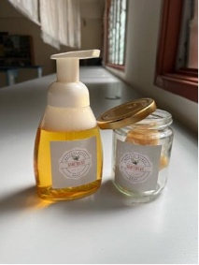  Soretreat | Positive | Negative | Positive | Less then existing products | Gentle/ soothing/ relaxing smell
Product A | Negative | Negative | Negative | Higher than other existing product | Strong and pungent smell
Product B | Negative | Negative | Negative | Average  With other existing product | Strong and pungent smell
Product C | Negative | Negative | Negative | Average  With other existing product | Strong and pungent smell

Readiness Level (TRL)

We had achieved Level 9 in TRL because our actual system was proven in
operational environments. Our product was first tested by the student in Kolej MARA
Kuala Nerang to get the actual result when used in daily life. We distribute our
product to the chosen student and a few staffs who just changed their workout routine. We created a google form to obtain reviews and feedback from the test subject (users). Therefore, we proceed with our product and present it on College MARA Kuala Nerang Innovation Competition (IIEC 2021). On that day, shortly after the presentation several students come to meet one of the team members, Laina to buy our product and from there we start our product among the students and our advisor, Mr Wan Ahamad Azran. We are very happy to know that our target to make a beneficial product for the students was achieved.

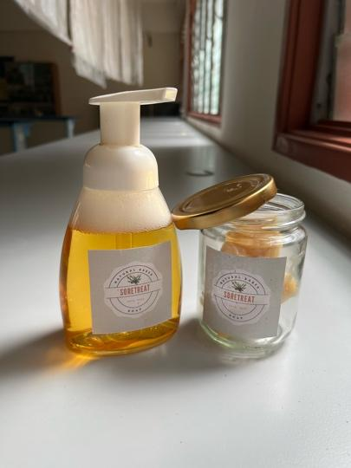
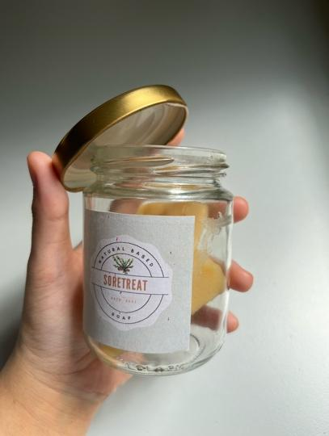
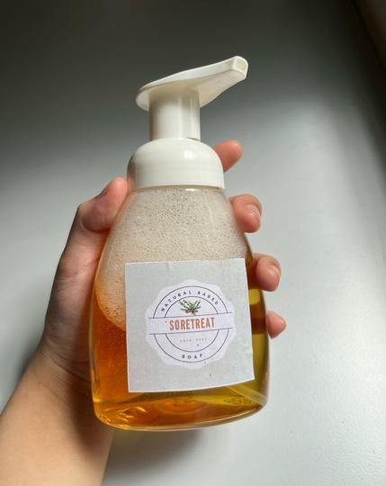
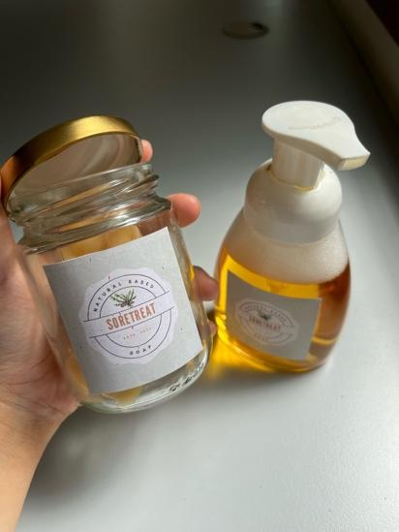
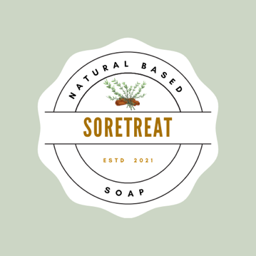

F) CONCLUSION

The results of the research demonstrate the effectiveness of SoreTreat natural soap in addressing the needs of individuals who engage in sports activities. Our product is made with safe, beneficial ingredients to ensure user safety and promote healthy skin. SoreTreat offers a gentle alternative to traditional treatments for Delayed Onset Muscle Soreness (DOMS) and does not contain any harmful chemicals that can irritate the skin. Our soap is made with pure essential oils, providing aromatherapeutic benefits and avoiding the dryness or skin irritation often seen with synthetic ingredients. To prevent rhabdomyolysis and other associated risks, it is important to treat DOMS correctly, and SoreTreat is an excellent solution to achieve this.

