ANANAS COMOSUS ALL IN 1 KIT

INTRODUCTION
Malaysia is one of the world’s largest producers of pineapple which brings in over RM600mil to the country’s economy. Solid waste or biomass waste is the by-product from pineapple processing or after harvesting the pineapple plants. Normally, pineapple will be processed to produce jam, juice, cordial, vinegar, and food flavouring. The process of making pineapple products yields biomass waste such as core, peel, crown, and stem. After harvesting, the pineapple waste is usually burnt or left on the ground. The waste from the pineapple plantation industry will disturb the environmental balance and contribute to environmental pollution. Due to this issue, the creation of products based on pineapple waste can conserve the environment while increasing the activities in pineapple plantation and processing. Such innovations can have a positive effect not only in economic profit and environmental cleanliness, but also maintain pineapple plantations.
PROBLEM STATEMENT
When you cut fruit and exposed for a while, the fruit will become brown. The process occurs when chemicals inside the fruit come into contact with oxygen in the air. This process called enzymatic browning which produces melanin, the same dark brown pigment that colours human hair, skin, and eyes. The enzyme responsible for the browning is called polyphenol oxidase (or PPO).
Water filtration is the process of removing or reducing the concentration of particulate matter, including suspended particles, parasites, bacteria, algae, viruses, and fungi, as well as other undesirable chemical and biological contaminants from contaminated water to produce safe and clean water for a specific purpose. These days, water filtration method commonly uses chemically made substances. This could be harmful and the sources are limited. Activated carbon that is used in water filters are made from charcoal. Charcoal is non-renewable and has only a finite amount. On the other hand, the dust from chemically made activated carbon can lead to blockages.

PROJECT BACKGROUND
This innovation project which is named Ananas Comosus All in 1 Kit is a substitution for water filtration system and antioxidant powder (prevent fruit brownish) into a more environmentally safe solution. The kit contains pineapple leaf fibre paper, pineapple peel waste powder and pineapple peel activated carbon. Our product is mainly made by using pineapple waste which as pineapple peel waste and pineapple leaf.

OBJECTIVES
- To extend the used of wastage of unused pineapple parts in Malaysia.
- To provide other option in order to maximize the nutrient content in filtered water.
- To offer a safer alternative in making activated carbon rather than using harmful charcoal.
- To propose another way to maintain the freshness of sliced fruits without changing its taste.

METHODOLOGY
- Preparing pineapple peel waste (PPW) powder
- Pineapple peel waste was washed under tap water.
- The pineapple peels were the dried in a ventilated oven at 60°C for 48 hours and grounded to a fine powder.
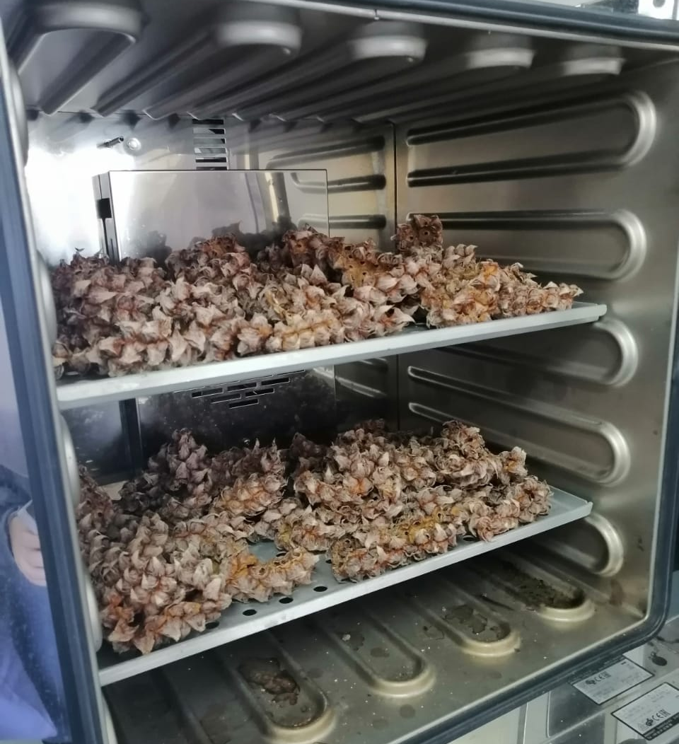
- The PPW powder was sieved.
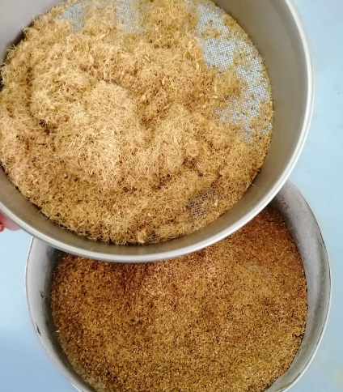

- Testing Pineapple Peel Waste (PPW) powder as antioxidant
1. An apple was cut into slices.
- The sliced apple is sprinkled with PPW powder.
- Step (ii) was repeated using salt and sugar.
- The apples were left exposed in air until it become browning.
- The observation was recorded.

- Preparation of Pineapple Leaf Fibre (PALF) paper
- Dried pineapple leaf was scrapped with a knife to obtain its fibre.
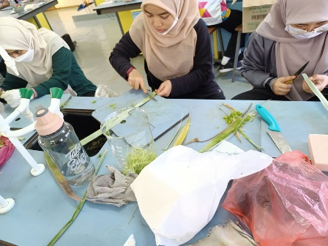

- The PALF is collected into a beaker and weighed.
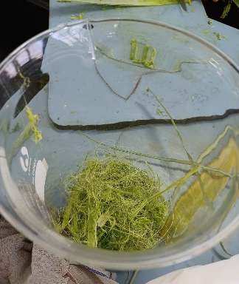

- 30g of PALF and 50 ml of water are added to the blender until it forms like
mush.
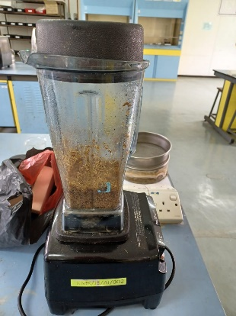

- The slurry is poured over a filter cloth and dry under the sun for 3 hours. The paper is gently removed from cloth.

- Preparation of activated carbon
1. 100g of pineapple peel waste (PPW) powder was mixed with 100ml, 9M
sulphuric acid and stirred.
- The mixture was maintained in an oven at 300°C for 3 hours in order for activation process.
- The mixture was taken out and washed with distilled water until pH is neutral (same as distilled water).
- The mixture was filtered and the activated carbon is obtained.

- Testing Water Filtration Kit
1. Put 2 pieces of PALF paper, activated powder and PPW powder by layer.
- Pour 250mL of dirty water through the layers.
- Observe the changes in water.

The effectiveness of Pineapple Peel Waste (PPW) as antioxidant were shown as below:
Sample | Observation
Time taken (min) | 0 | 40 | 180 | 240
Control sample | 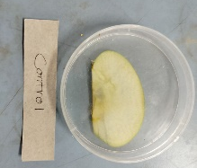 | 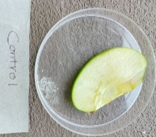  Browning started to appear | 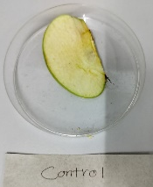  More browning appear | 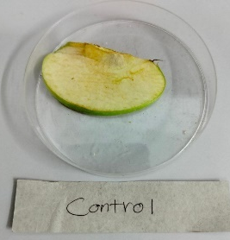  Browning become apparent
Sample sprinkled with Pineapple Peel Waste (PPW) Powder |  | 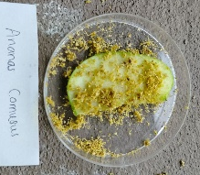  Still remains fresh | 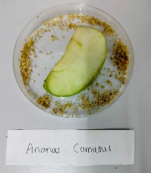  Still remains fresh | 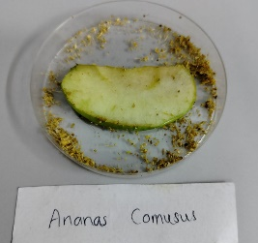  Small browning starts to appear
Sample sprinkled with sugar | 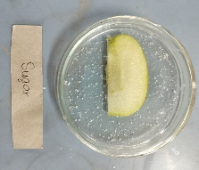 | 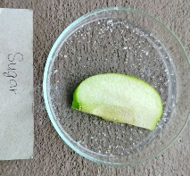  Still remains fresh | Browning at core starts to appear | 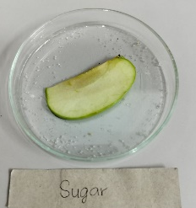  More browning
Sample sprinkled with salt | 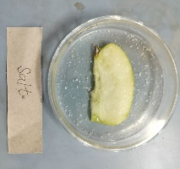 | 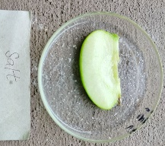  Still remains fresh | 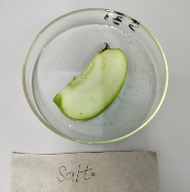  Still remains fresh | 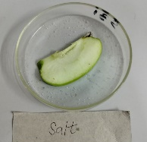  Still remains fresh

Based on our observation, the Ananas Comosus Powder was able to maintain the freshness and prevent fruit browning for maximum four hours. While the control sliced fruit started to browning after 40 minutes. Sliced fruit that was sprinkled with sugar started to browning after 3 hours, which is shorter than fruit that was sprinkled with Ananas Comosus Powder. Even though the fruit that was sprinkled with salt remained fresh until five hours, the taste of fruit will be more salty and will effect the natural taste of the fruit.

OUTCOMES
PRODUCTS | FUNCTION
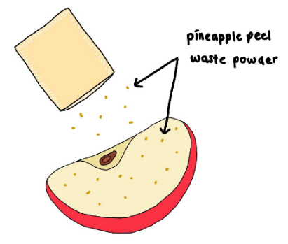
Pineapple peel powder is used as antioxidant powder to prevent fruit brownish and remain its freshness and taste

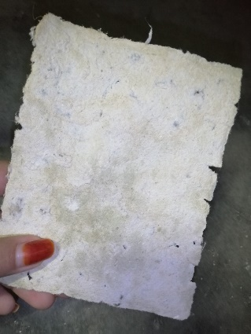 | 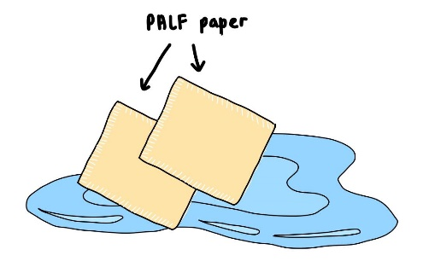  PALF paper is used as filter paper to filtrate water due to its structure that is high porosity and has remarkable interconnectivity between its pores
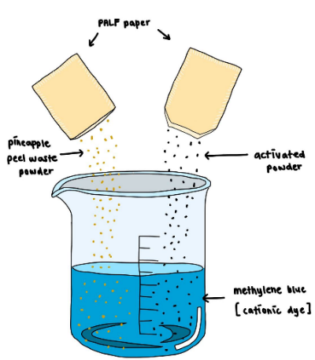
Pineapple peel powder and antixodant powder from pineapple peel is used as cationic dye adsorbent

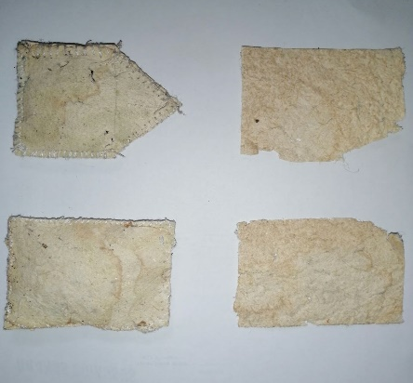 | 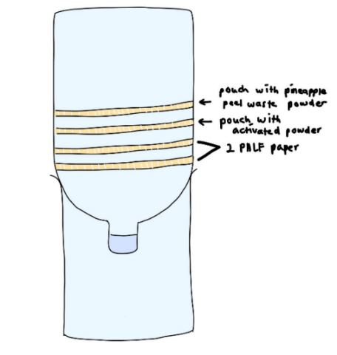  Pouch that containing pineapple peel powder and activated carbon are used in water filtration.
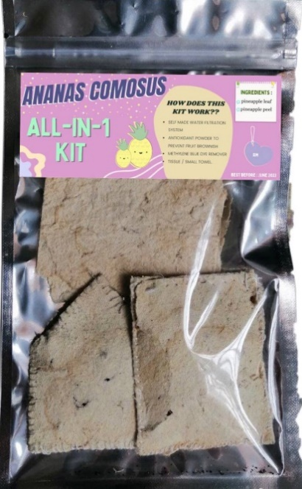
Final product

Assemble all the products into one pouch to make it look like a small convenient kit with various of function. We also produces Ananas Comosus Powder in a small bottle as alternative if consumer only need the antioxidant to prevent fruit browning. This bottle is easy to be used and can be carried anywhere.

CONCLUSION
Due to our kit’s compact size, users can bring this kit along with them during camping to be used as water filter. The idea and concept of our water filtration can help improve the water management system of our country to a more sustainable alternative. The Pineapple Peel Waste (PPW) Powder can prevent fruit spoilage without ruining the taste and even enhance the nutrient content such as Vitamin C. Our product mainly uses organic fruit waste as its main ingredient. This can maximize the use of fruit waste thus helping our country reach the 12 sustainable development goals.

